**SOURCE ONE** – The Mummification Process – Video

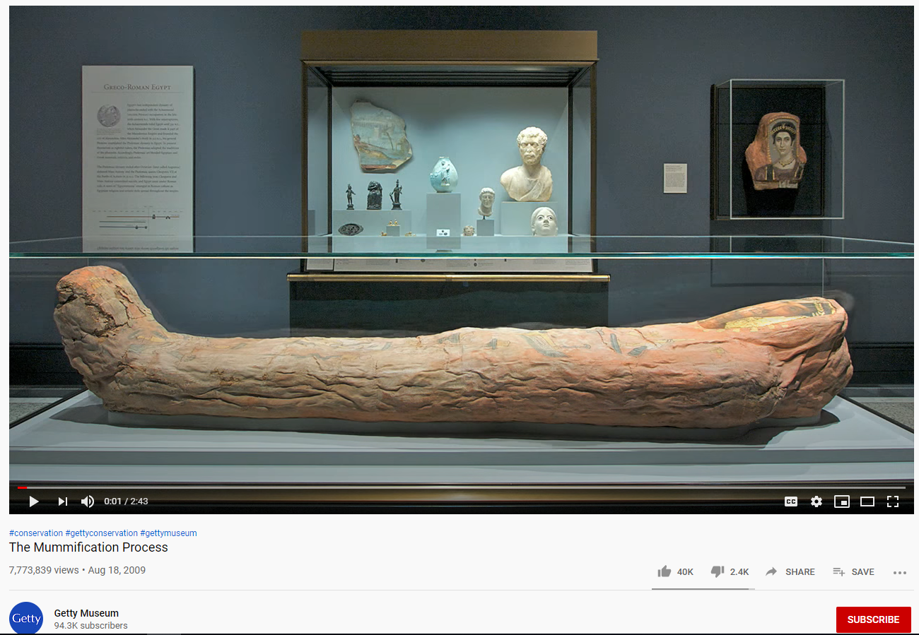<https://www.youtube.com/watch?v=-MQ5dL9cQX0>